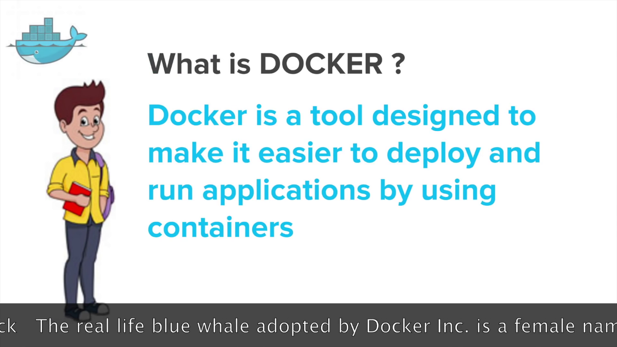

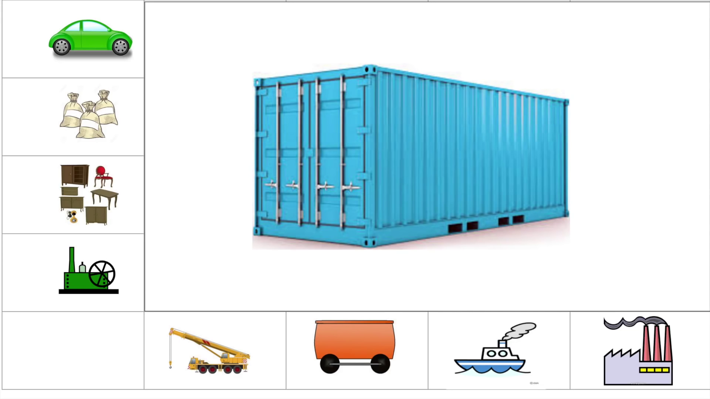

VM vs Container

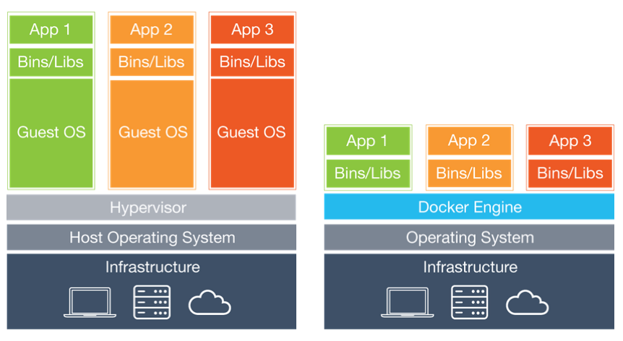

# [**etc/ bin/ and lib/**](https://stackoverflow.com/questions/16643142/what-do-these-directory-is-used-for-in-linux-etc-bin-and-lib)

* etc -> To keep configuration files
* lib -> To keep libraries that can be used by installed software or other softwares in your system.
* bin -> Binary files

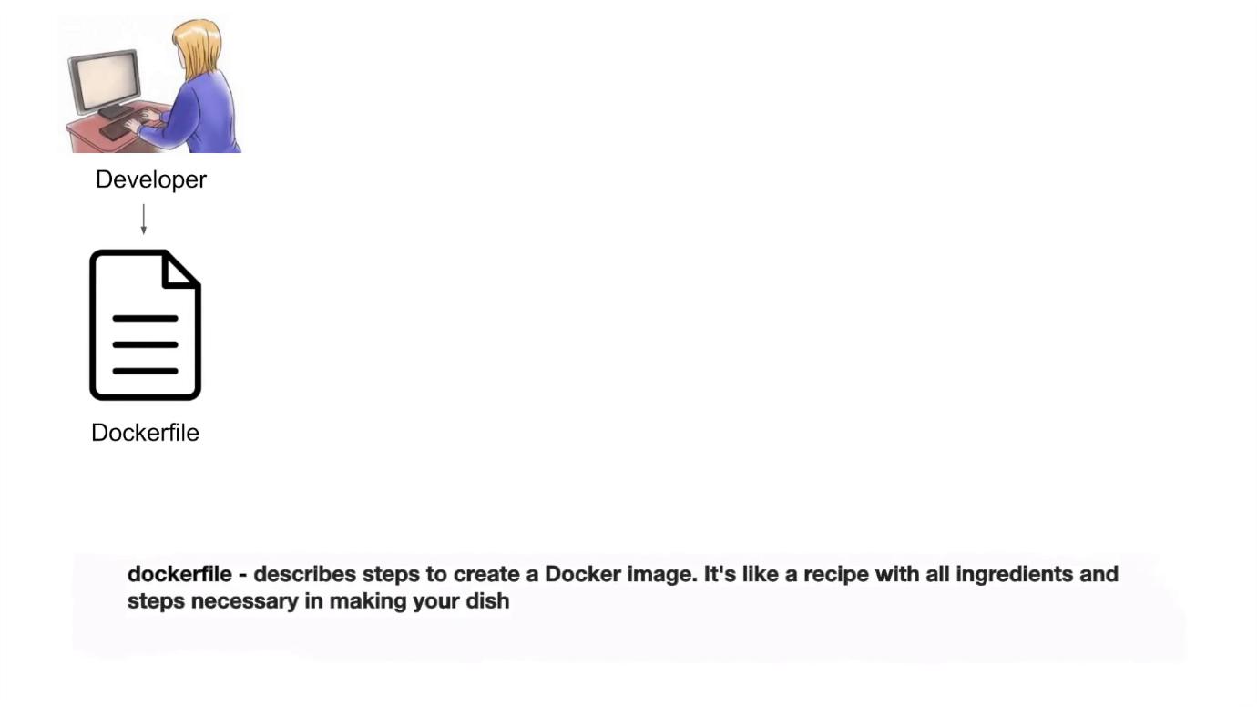

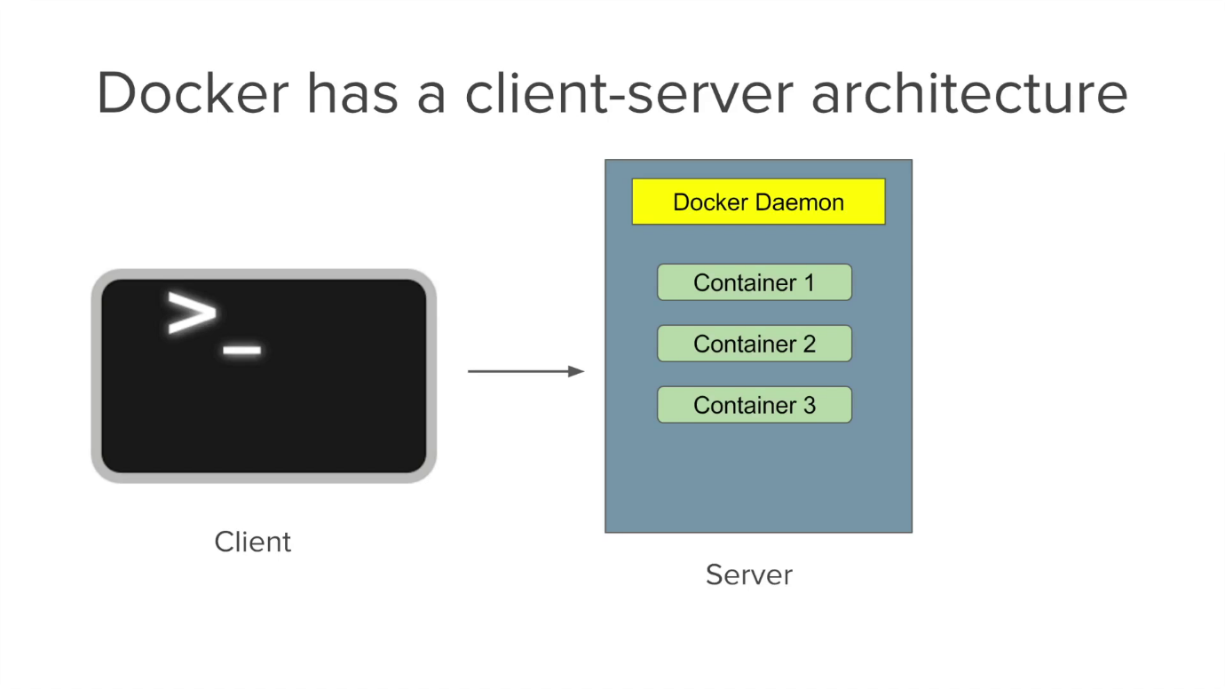

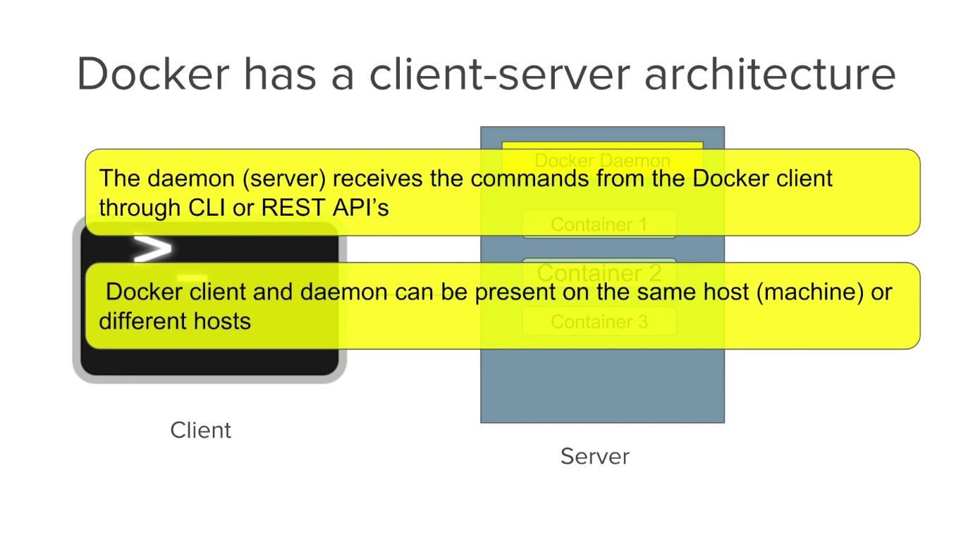

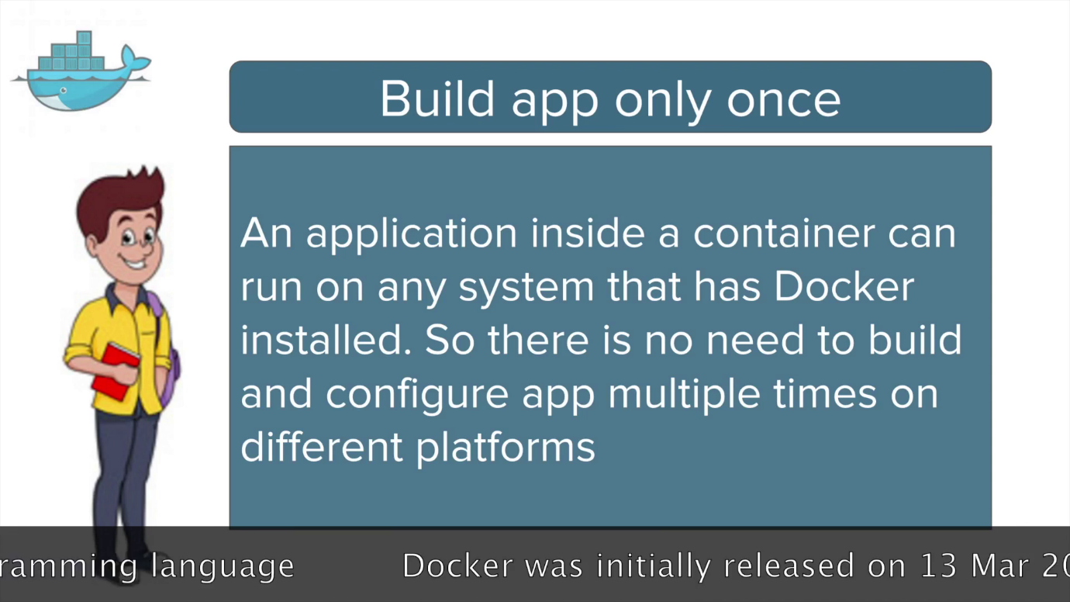

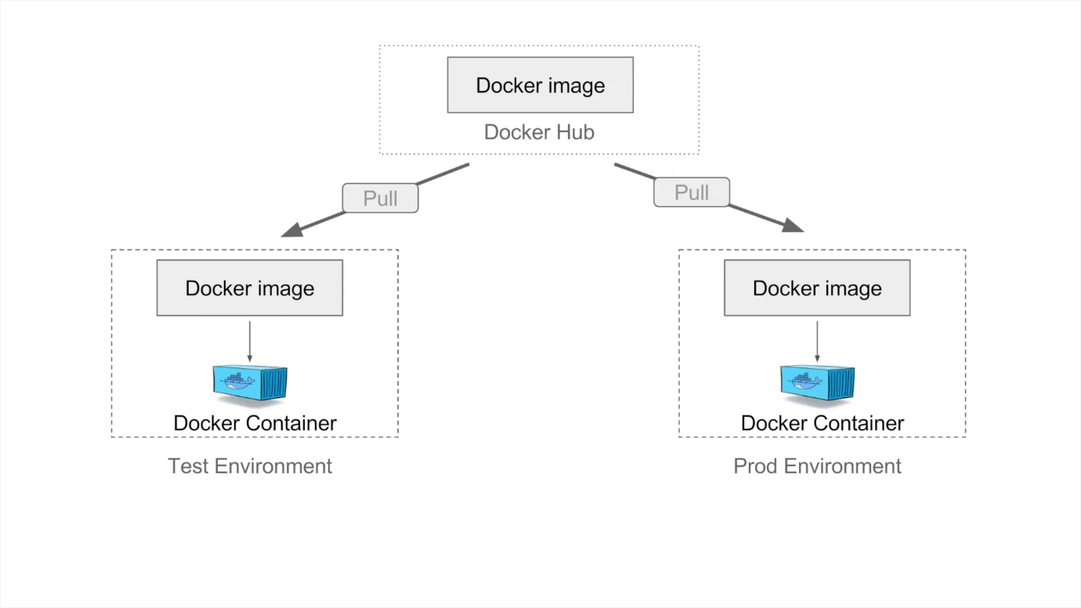

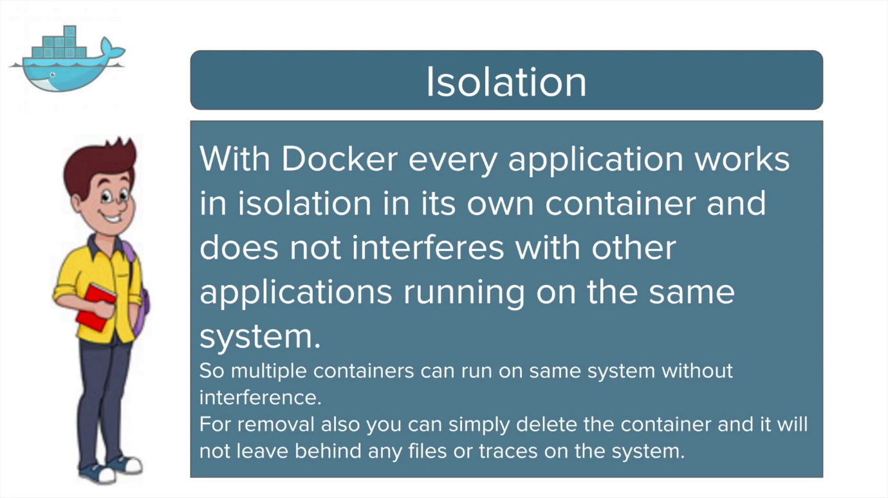

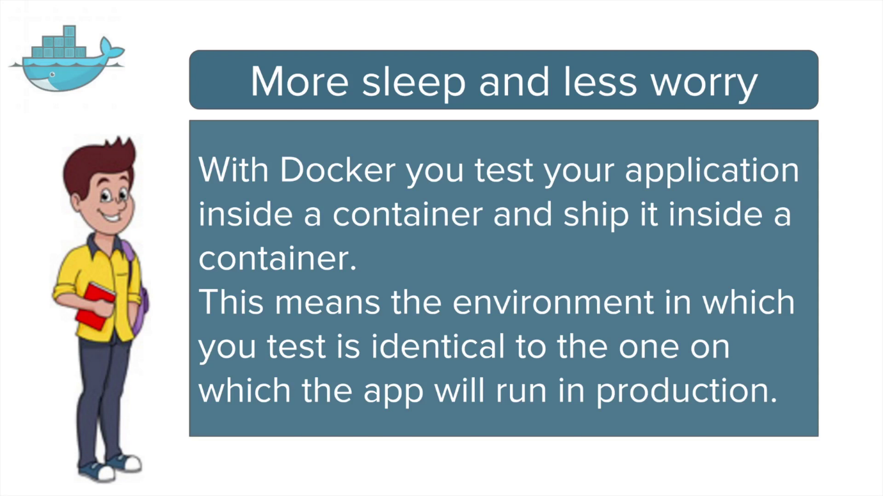

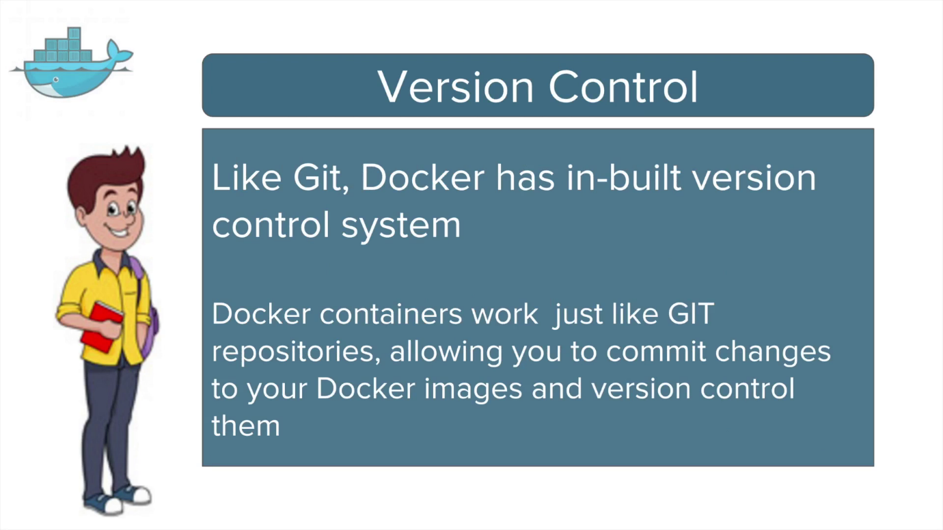

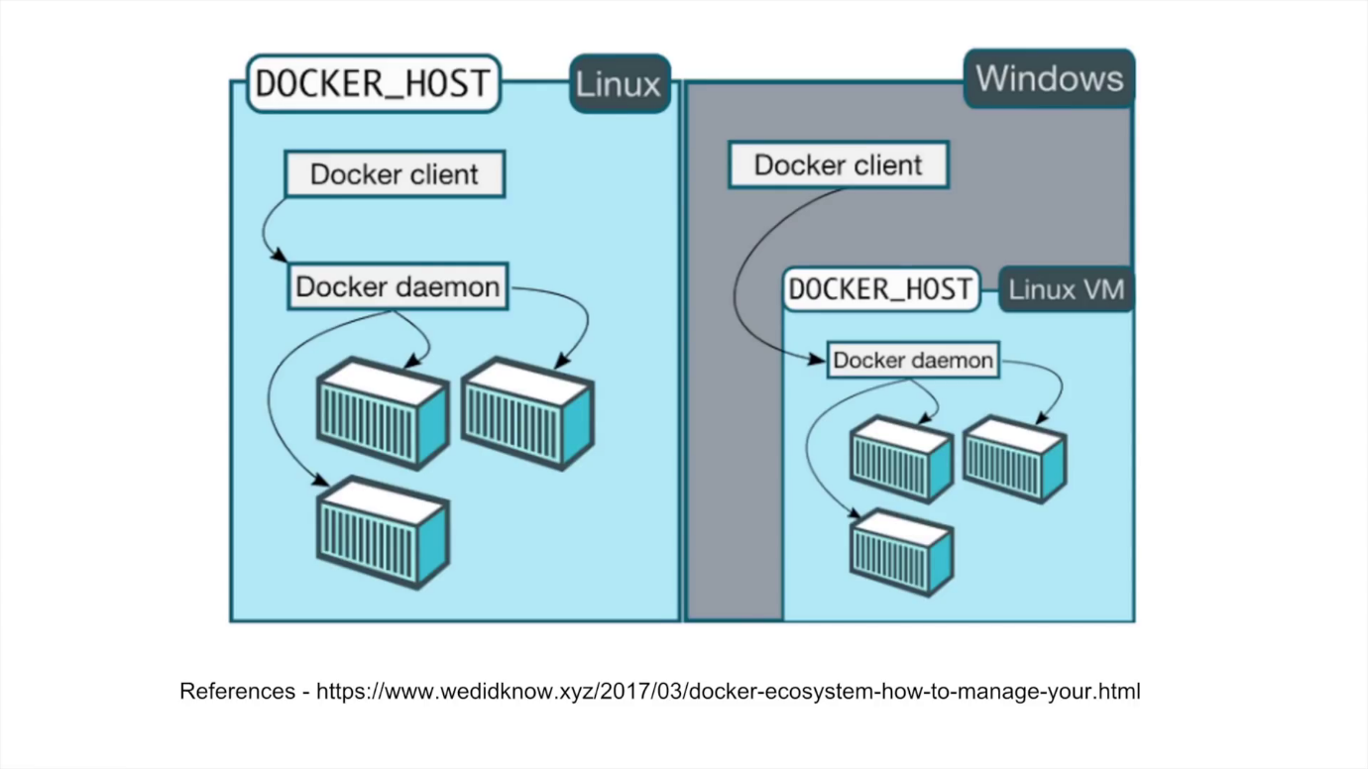

<https://www.cyberciti.biz/faq/install-use-setup-docker-on-rhel7-centos7-linux/>

**Docker commands:**

**Docker build :** Build an image from a Dockerfile

**Ex: docker build -t aaa-docker .**

**docker build -t aaa-docker -f /lakshman/Dockerfile**

**Docker tag:**

**docker tag SOURCE_IMAGE[:TAG] TARGET_IMAGE[:TAG]**

**Ex: docker tag aaa-dockerimg aaa-repo-can:data**

**Docker pull to download images from registry**

**Ex: docker pull aaa-core-docker-candidates.repo.lab.pl.alcatel-lucent.com/aaa-dockerimg:19A.20190516061205**

**Docker images – to list of all the docker images**

**Docker ps – to list running containers**

**Docker ps or docker container ls – to list of all running containers**

**Docker run image-name : to star the container**

**Docker stop continer-id : to stop the container**

**Docker rmi docker-image/img-id : to delete the docker images**

**docker run -itd image-name/ID : to run docker image**

**docker exec -it img-id bash : to login into the docker container**

**copying files from host to container:**

$ docker ps

CONTAINER ID IMAGE COMMAND CREATED STATUS PORTS NAMES

72ca2488b353 my_image X hours ago Up X hours my_container

docker cp foo.txt 72ca2488b353:/foo.txt

docker cp 72ca2488b353:/foo.txt foo.txt

**Helm:**

[Helm](https://www.helm.sh/) is a package manager for Kubernetes that allows developers and operators to more easily package, configure, and deploy applications and services onto Kubernetes cluster.

Helm helps you manage Kubernetes applications — Helm Charts help you define, install, and upgrade even the most complex Kubernetes application.

Charts are easy to create, version, share, and publish — so start using Helm and stop the copy-and-paste.